Application Note
How can the DISTO™ sketch app benefit you during the planning phase?

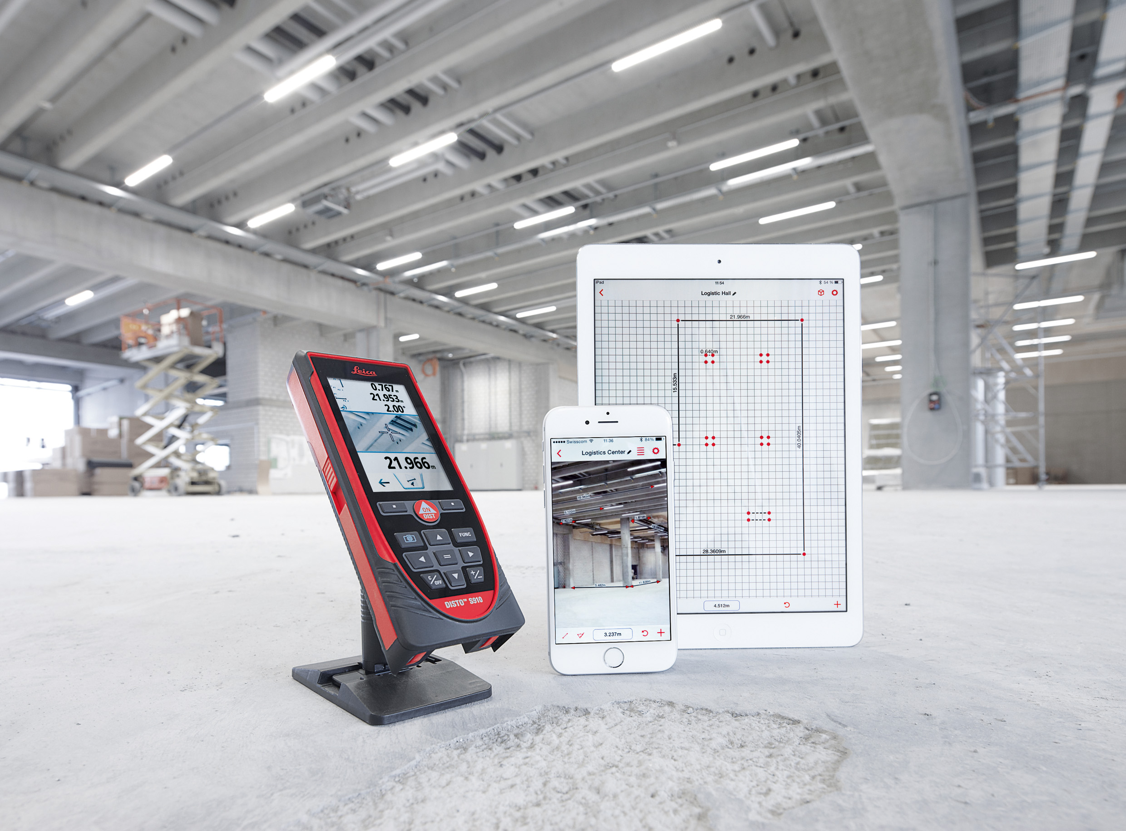

The only difference between a bad plan and a good plan is the amount of information it contains and whether that information is correct. So in theory every plan can be a good plan and the recipe for it is simple; gather a lot of reliable information. However in practice this is much harder to achieve, since the information is hard to get and expensive, or there simply is not enough time to obtain it. If an investor had every piece of information available to him, his choices would carry a 0% risk, and if a construction plan was perfect, everything would be built on time and within budget. Unfortunately it is not like that, but what helps to take a big step towards this kind of scenario are the functions provided by the DISTO™ sketch app combined with a DISTO™ device. Information is gathered quickly, reliably and without any significant extra costs.

Facts where the DISTO™ sketch app can bring in its strength to investors, architects and builders

Gathering quick and reliable information for investing purposes
In many cases there are numerous reasons why a building has to be re-measured. Here the challenge is to be time and cost efficient, while at the same time still gathering precise data. DISTO™ sketch app is the perfect tool that will help you achieve all that. With a DISTO™ device you can precisely measure all dimensions with ease and adding Sketch app makes your work really valuable and efficient, since you are able to create the layout of the building at the same time you are measuring it. Everything is documented and the information can later be used with different desktop software without any extra work required. However to make reviewing data easier, sketch app automatically records your location and time the work was carried out. All this allows professionals to make fast and precise re-measurements of small or large buildings.

Improving existing plans on the spot
One of the strong features of sketch app is the improvement of existing plans with information from the real world. For example, a building site organization plan is something that has to be done with care, experience and information. The first two come with excellent personnel, and the last one is covered by the DISTO™ sketch app. You can import an existing plan to sketch app as an image file and do all your work directly on it. While cruising the construction site and navigating the layout which is already drawn, you are always aware of your precise position. This way you can easily work out where things like construction roads, landfills and toilets should be located, making it possible to design the most effective construction site. While doing that, you can document everything in sketch app with lines, distances and notes. You can even plan the precise movements of large-sized machinery and building elements. Finally you are able to export a file in PDF format with detailed measurements from the DISTO™ device for further analysis.

Documenting the condition of a potential site or building
Before designing and building can begin, someone has to document the condition of the construction site such as a house, land, hill or other. Traditionally, a worker would take a normal camera, capture conditions, and then later in the office sort out all the photographs with their notes. This approach is very much open to error, but with DISTO™ sketch app this can be avoided. Capturing images directly with a smart phone or a tablet, transferring measurements to it, as well as recording any notes on it which are required, your data will never be lost or misplaced again. Even better, when using it on your phone, you will always have the ultimate documentation tool at your disposal!

