Application Note
How can DISTO™ sketch app benefit you during the construction phase?

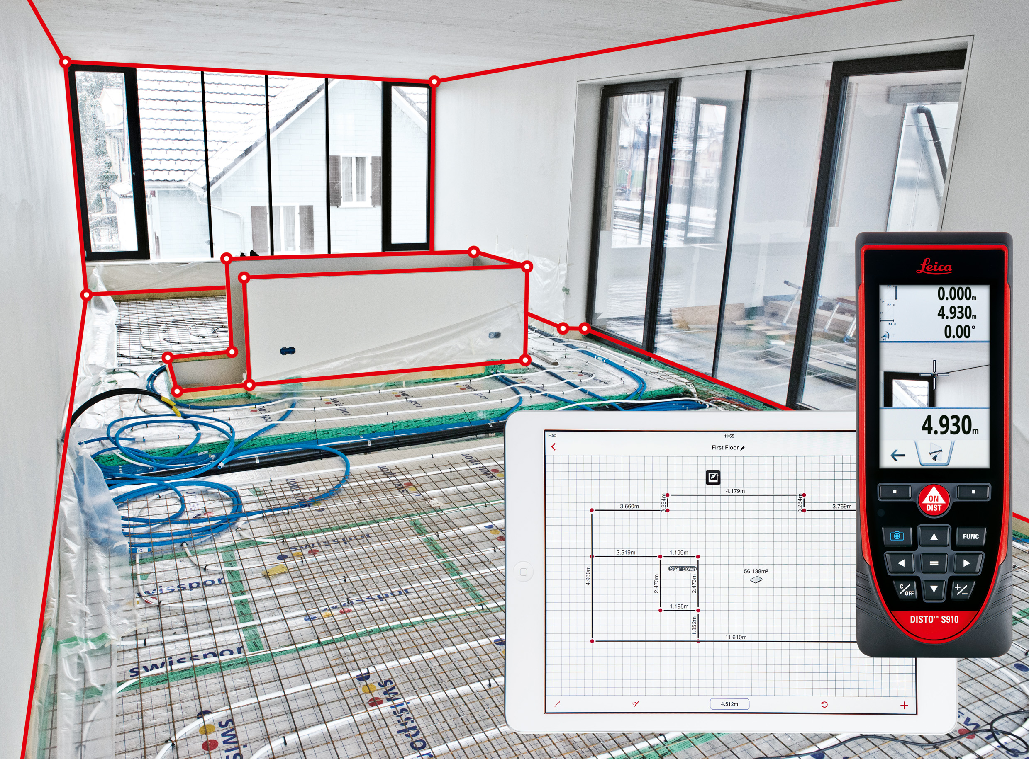

Information technology is rapidly changing the construction industry. This means that more and more information is being digitalized, and the benefit of this is that gathering information as well as exchanging this information is faster and more reliable. But the real challenge for the measurement industry is to capture and document what is in the real world and transfer it to the digital world in a fast and reliable way. There is already a lot of really specialized software catering to numerous specific problems, but it is only as good as the information the user puts in. This is where DISTO™ sketch app comes in to fill in the missing pieces.

Facts where the DISTO™ sketch app can bring in its strength to architects, surveyors, builders, project managers, and finishing work professions

Verifying what is designed and what is built
Verifying construction progress is a critical component of a fluid work process and for avoiding costly mistakes. With the help of DISTO™ sketch app and a DISTO™ device, you can create a precise floor plan of the building in an intuitive and user-friendly way any day. Verification is simple and reliable. Just measure the distances with a DISTO™ device and information will be automatically transferred to the app, enabling you to send this data instantly to your office team. At one moment you can document the construction site, and the next moment your office team is able to verify the information, which means quality feedback is possible while you are still at the construction site! With this tool, you are also able to adapt to a changing situation very quickly without losing any reliability of data. Just open the app and continue to work from the changes that have been made. At the end of the day the whole construction process can be precisely monitored, this effectiveness greatly reduces the possibility of human error.

Documenting and reporting situations by Taking Pictures and measurements
Documenting and reporting situations such as incidents, building errors, designer mistakes and other errors is now as easy as can be. With the help of DISTO™ sketch app you are able to capture the situation quickly with an image and put relevant DISTO™ measurements into it. Even more, you can make notes to describe any situation right on the picture; which make sketch app a professional tool for any situation. When you feel that the situation is sufficiently documented, simply forward the information to the interested party with only a few commands. Everyone will understand the situation with just a glance at the picture. For even easier reviewing of data, sketch app will automatically record your location and time the work was carried out. With this approach documentation is quick, reliable, straight to the point and easy to use.

Verifying dimensions with Imported Images
Are you comparing what is in the real world and what was designed? Why not have both on the same screen and make the process as simple as possible? Upload an image of the floor plan to the DISTO™ sketch app, and with the help of a distance measuring device you will easily be able to check all the lengths and record any irregularities. You will not have to carry a hard copy floor plan, a pen or a measuring device everywhere you go on a construction site. Just have a DISTO™ distance meter and your smart phone in hand and you will be able to do the job quickly and professionally. You can make notes and describe any situation, as well as being able to quickly forward all digital data to the responsible project team. This will make your work truly valuable and efficient. Finding a mistake and reporting it to the designers is done in a matter of minutes, making this a great way for project managers to manage real time construction.

