Application Note
Experience the Leica DISTO™ S910 for facade contractors

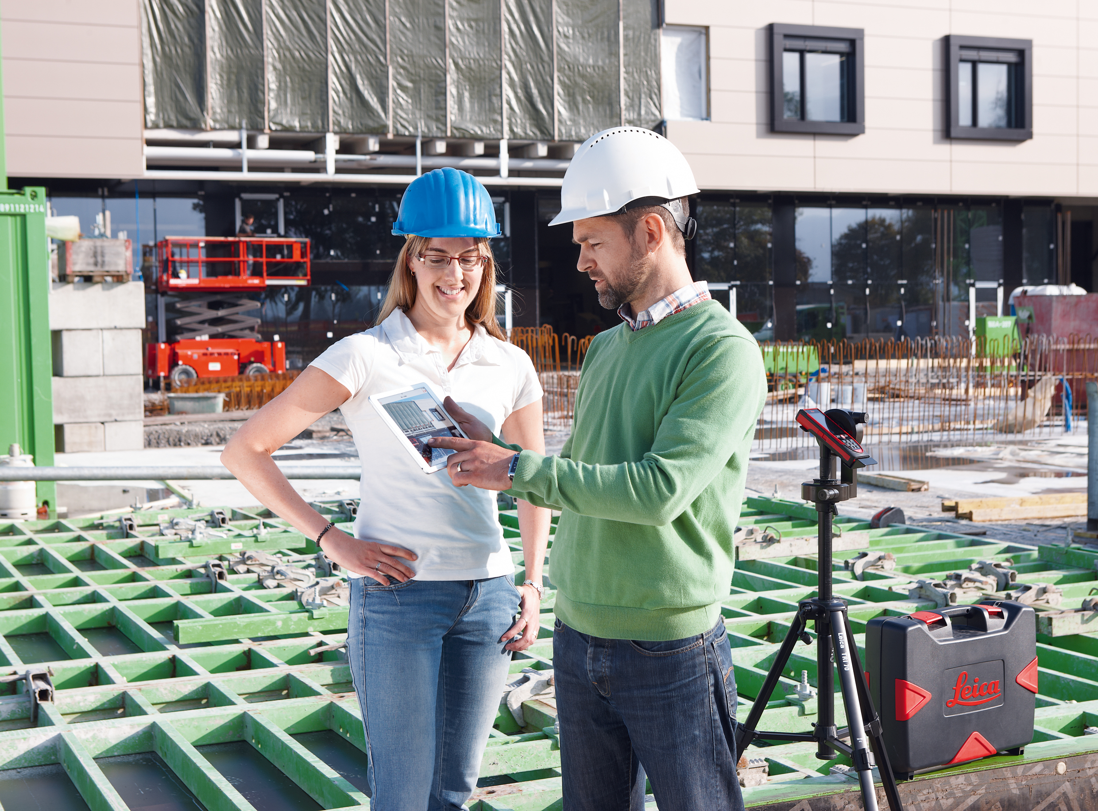

To measure a façade of a building is very time consuming. You can maybe take some measurements from the outside but when it comes to windows, balconies etc. you need to enter the building and measure from inside. Sometimes you do not have access to apartments especially if you need to plan a renovation. Of course an alternative is to hire a surveyor, but this is quite expensive and you are dependent on the surveyors capacity to do the job. Another common option to fulfil the task is to count bricks and tiles and start to estimate the dimensions, but of course this leads to sometimes significant deviations, which as a consequence costs additional time and money.

Facts where the Leica DISTO™ S910 can bring in its strength to facade contractors

Easily get distances or levels of not reachable objects
By use of the Point to Point function it is easy to measure any distance between objects or points - including height difference and even inclination (e.g. the roof). Therefore it is easy to control existing plans whether the data is equal to the real situation. Also all data can be transferred right into a photo or sketch on your smartphone or tablet using the free DISTO™ sketch App.

Capture the outline of a façade including openings like windows
Before starting a plan it is necessary to capture the real situation. Use the DISTO™ S910 on the robust Leica tripod with the FTA360-S adapter with fine adjustment for convenient aiming. Position yourself in front of a building and measure all relevant points with the dxf-function. That way you can create up to 20 dxf files with 30 points each. If 30 points are not enough or you need to reposition yourself during the measurement, just start a new file and measure the first 2 points from your last file again. The files can easily be brought together using a professional CAD software. Since photos of all measured points are saved automatically, it is easy to follow the measurement data when back in the office or after handing over the data to another person for further processing. Use the automatically saved wall plan to get the front view as a 2D file.

Besides these S910 specific arguments of course no Façade contractor should miss using a Leica DISTO™ product, especially when he wants to benefit from:

- Precision
- Professionalism
- Reliability
- Innovative solutions

