Application Note
Experience the Leica DISTO™ S910 for landscapers and gardeners

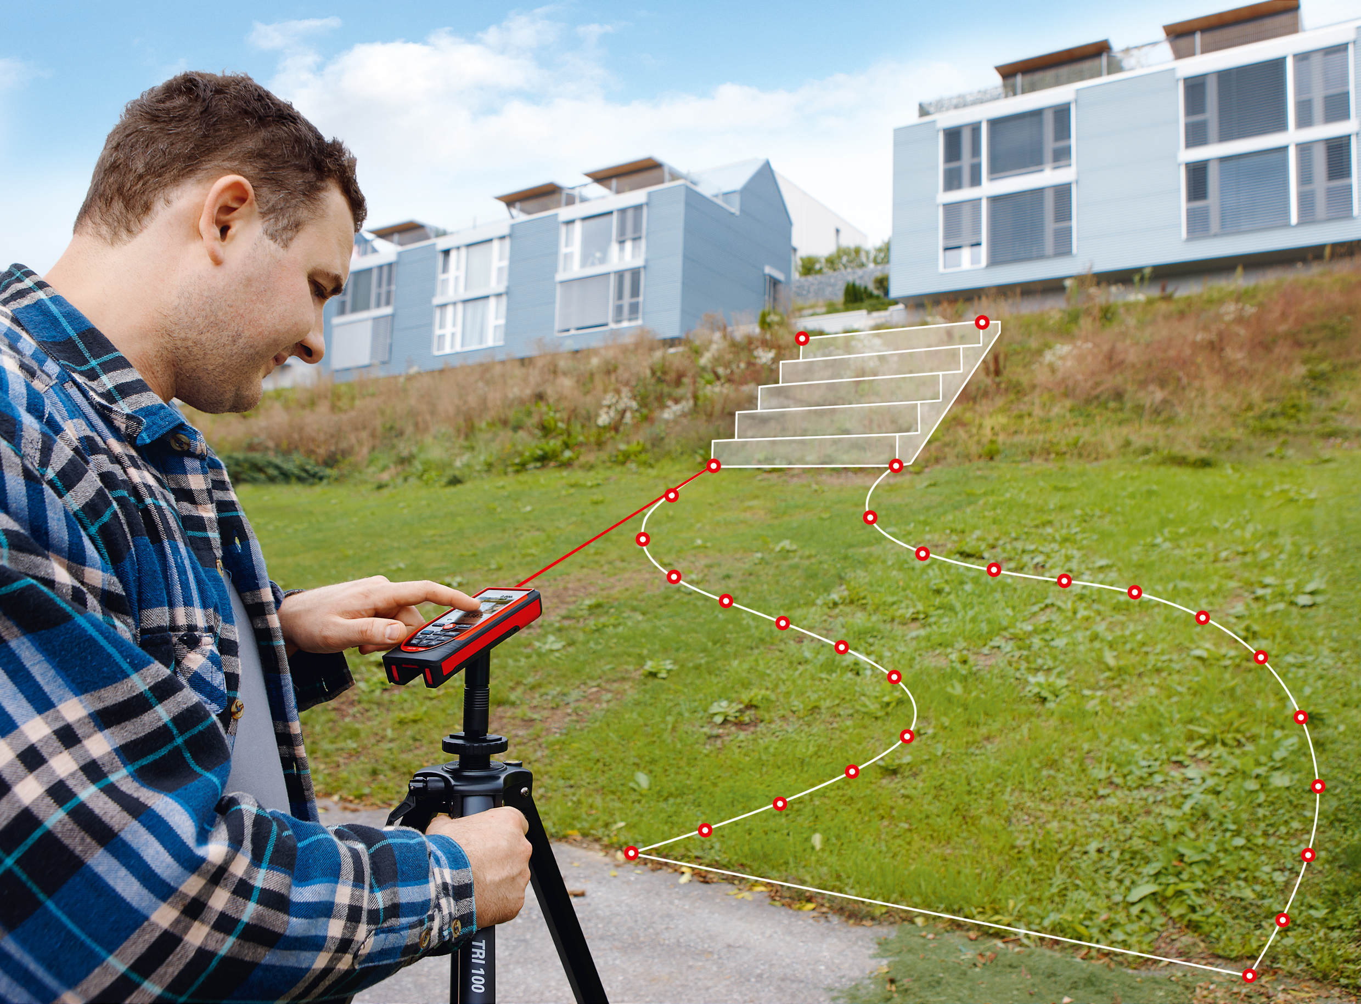

Measuring land for planning your garden and landscape tasks is quite important. In the past it was very cumbersome to measure dimensions by using long tapes. To get even heights another tool was necessary. Since hiring a surveyor for such tasks is relatively expensive and takes time. As a matter of fact in most cases jobs were planned with
a lot of estimations in there. Material was missing or too much material was at the job site and so additional transport costs were necessary or time delays were fact. With the Leica DISTO™ S910 this is history. It is now easy to create professional sets of data for properly planning the task.

Facts where the Leica DISTO™ S910 can bring in its strength to landscapers and gardeners

Capture the reality
By use of the Point to Point function it is easy to measure any distance between objects or points - including height difference and inclination. Therefore it is easy to control existing plans whether the old dimensions are correct or have changed during the years. Also all data can be transferred right into a photo or sketch on your smartphone or tablet using the free DISTO™ sketch App.

Measure the outline of a land
If no data is available a plan must be created first. Use the DISTO™ S910 on the robust Leica tripod with the FTA360-S adapter with fine adjustment for convenient aiming. Position yourself on a central place and measure all relevant points with the dxf-function. That way you can create up to 20 dxf files with 30 points each. If 30 points are not enough or you need to reposition yourself during the measurement just start a new file and measure the first 2 points from your last file again. That way the files can easily be brought together using a professional CAD software. Since photos of all measured points are saved automatically, it is easy to follow the measurement data when back in the office or after handing over the data to another person for further processing.

Measure even 3D files or wall plans (for height profiles)
By using the 3D data of the measured dxf file all elevations are recorded evenly. So no additional step to measure the heights between points is needed. Get all data right in one file for use in the CAD software. By using the automatically created wall plan it is possible to measure and capture a height profile.

Know the amount of relevant material by use of the Smart Area function
Just measure the corner of any land – clock- or counterclockwise – and get the area. No matter how complex the shape of this area is. If you need the volume for Cut & Fill calculations, you can start with the calculator on the DISTO™ where the area is automatically entered, and then multiply by the height or depth to get the cubic meter of material. If needed divide by the maximum possible truck load and you know how many trucks you will need.

X-Range Power technology
The extraordinary range of this product together with the digital pointfinder allows you to evenly measure large properties up to 300m.

Besides these Leica DISTO™ S910 specific arguments of course no Landscaper or Gardener should miss out on using a Leica DISTO™ product, especially when he wants to benefit from:

- Precision
- Professionalism
- Reliability
- Innovative solutions

