Application Note
Experience the Leica DISTO™ S910 for roofers

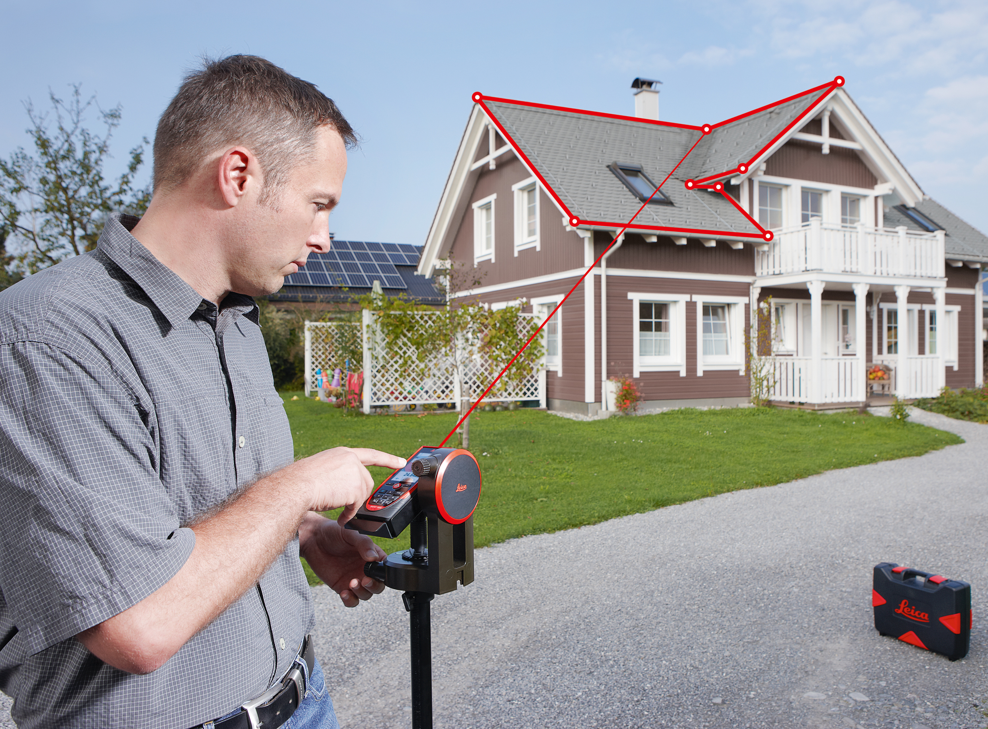

To measure a roof of a building is very time consuming. You need to climb the roof which is sometimes dangerous, especially if it is wet and the roof is slippery. Also you will hardly have target points, so you need an assistant who needs to go on the roof as well. Of course an alternative is to hire a surveyor but this is quite expensive and you are dependent on the surveyors capacity to do the job. Another common option to fulfil the task is to count bricks and roof tiles and start to estimate the dimensions, but of course this can lead to some significant deviations which as a consequence costs additional time and money.

Facts where the Leica DISTO™ S910 can bring in its strength to roofers

Easily get distances, height differences and inclinations
By use of the Point to Point function it is easy to measure dimensions of a roof. With two measurements you can get horizontal distance, slope distance, height difference and even the inclination. All can be transferred right into a photo or sketch on your smartphone or tablet using the free DISTO™ sketch App.

Capture the outline of a roof including chimneys or photovoltaic installations
If no data is available a plan must be created first. Use the DISTO™ S910 on the robust Leica tripod with the FTA360-S adapter with fine adjustment for convenient aiming. Position yourself in front of a building where the measuring points are visible and measure all relevant points with the dxf-function. That way you can create up to 20 dxf files with 30 points each. If 30 points are not enough or you need to reposition yourself during the measurement, just start a new file and measure the first 2 points from your last file again. The files can easily be brought together using a professional CAD software. Since photos of all measured points are saved automatically, it is easy to follow the measurement data when back in the office or after handing over the data to another person for further processing. By using the 3D file all data for further processing is available, including inclinations and height differences.

X-Range Power technology
The extraordinary measuring performance of the S910 allows you to measure the unfavorable surface of roof tiles, even over longer distances and if aiming tilted to the tile surface.

Besides these S910 specific arguments of course no Façade contractor should miss out on using a Leica DISTO™ product, especially when he wants to benefit from

- Precision
- Professionalism
- Reliability
- Innovative solutions

