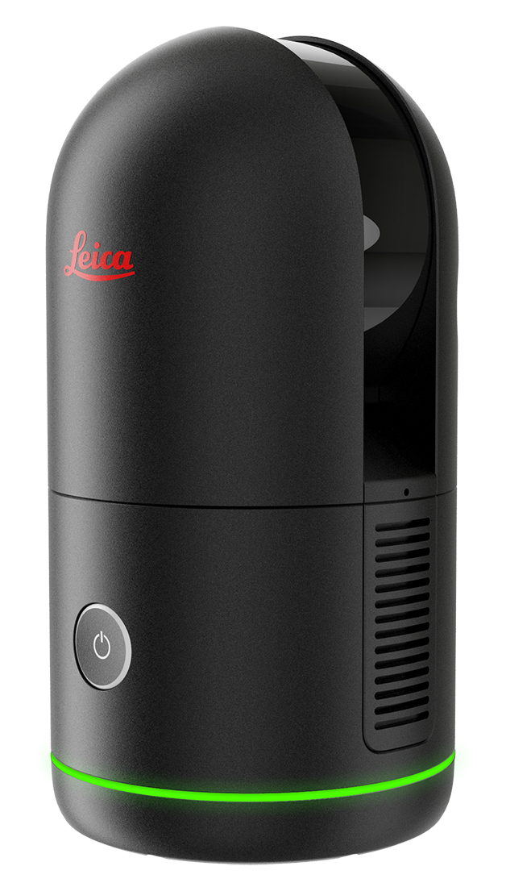
BLK360
Updating Firmware

- Make sure to have a fully charged battery before
updating the BLK360 firmware.

- Download the latest version of firmware from the Firmware Update page:

https://shop.leica-geosystems.com/leica-blk/blk360/firmware

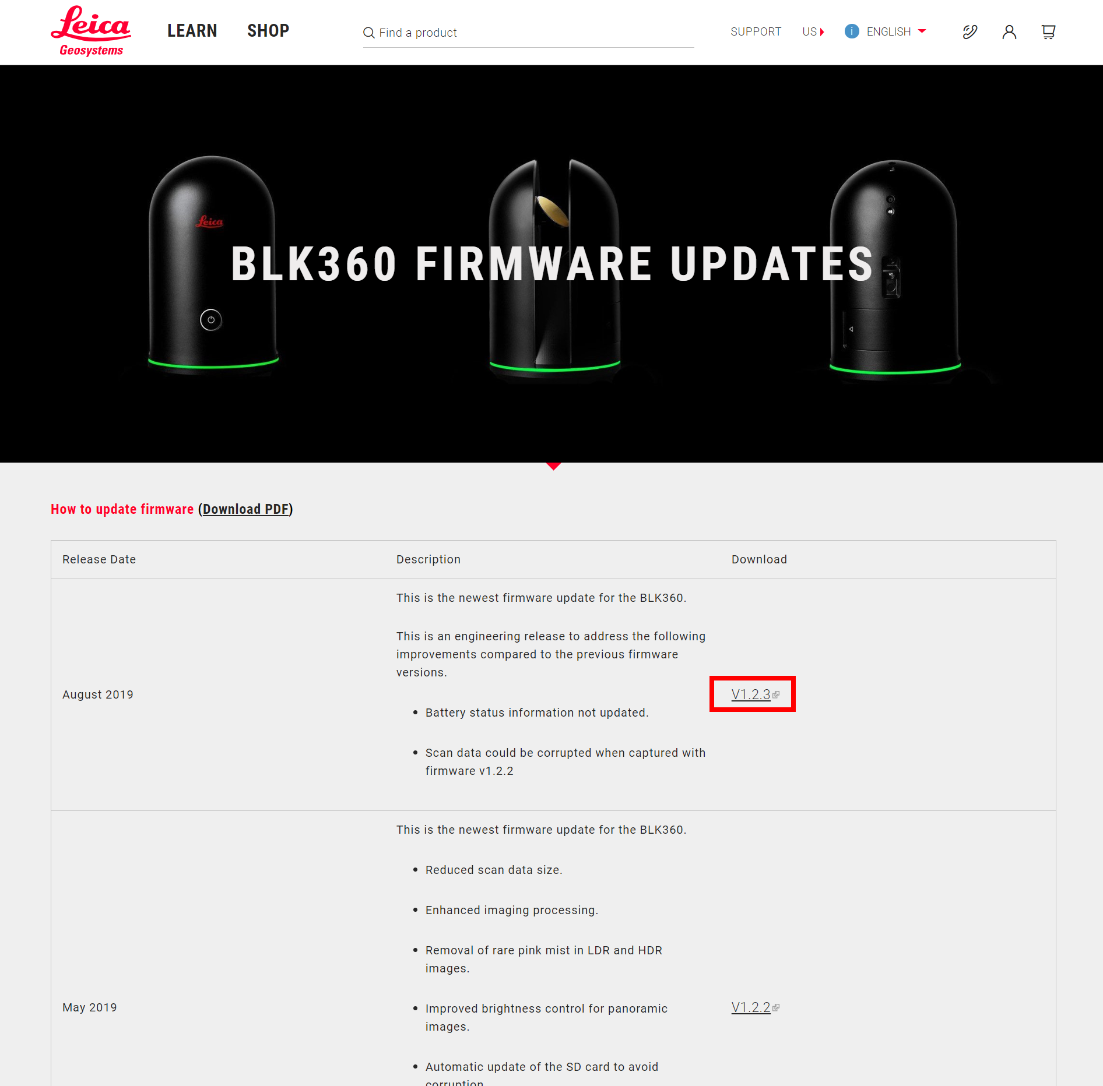

- Save this ‘.swu’ file in a location that you’ll be able to find.
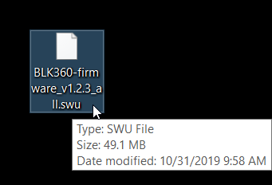

- Turn on the BLK360. Disconnect your computer from your office or home Wi-Fi and connect to the BLK’s Wi-Fi.
  - It may prompt you for a password. The Wi-Fi password can be found on the inside of the battery cover door. Enter the password exactly as it is written (including the dashes).
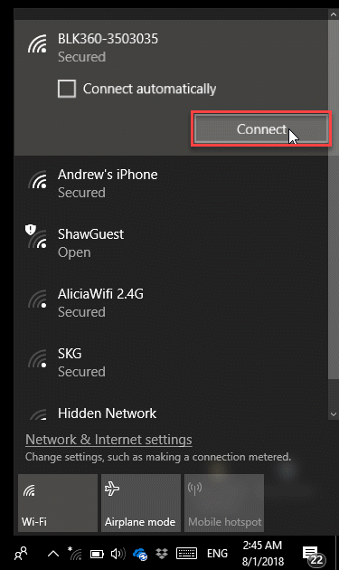
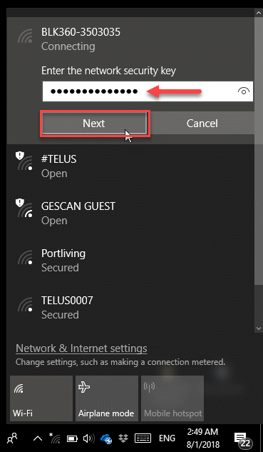

- Open your internet browser (you won’t have an internet connection). Type in the following address and hit ENTER.

  - http://192.168.10.90:8080

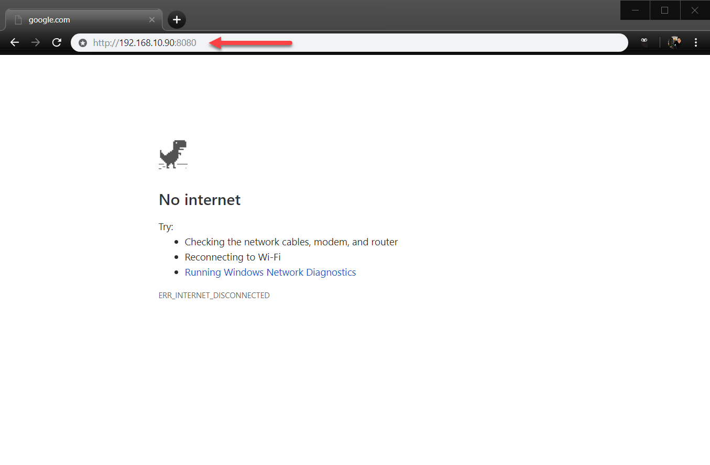

- Click ‘UPDATE FIRMWARE’
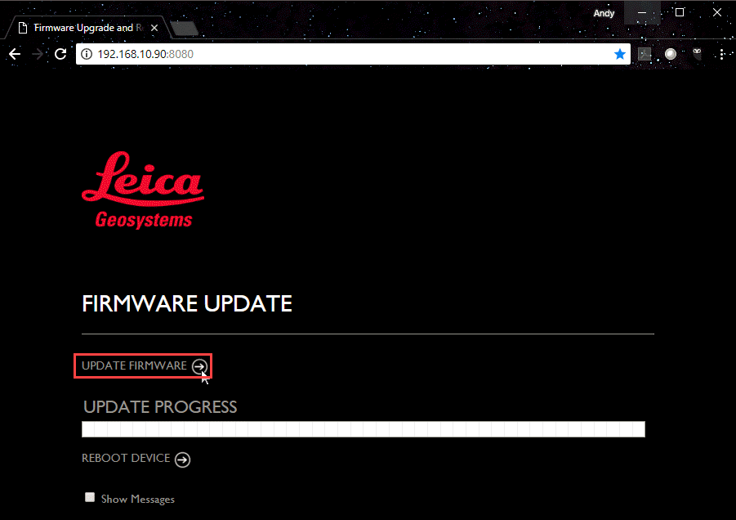

- Navigate to the ‘.swu’ file that you downloaded earlier. Click ‘Open.’

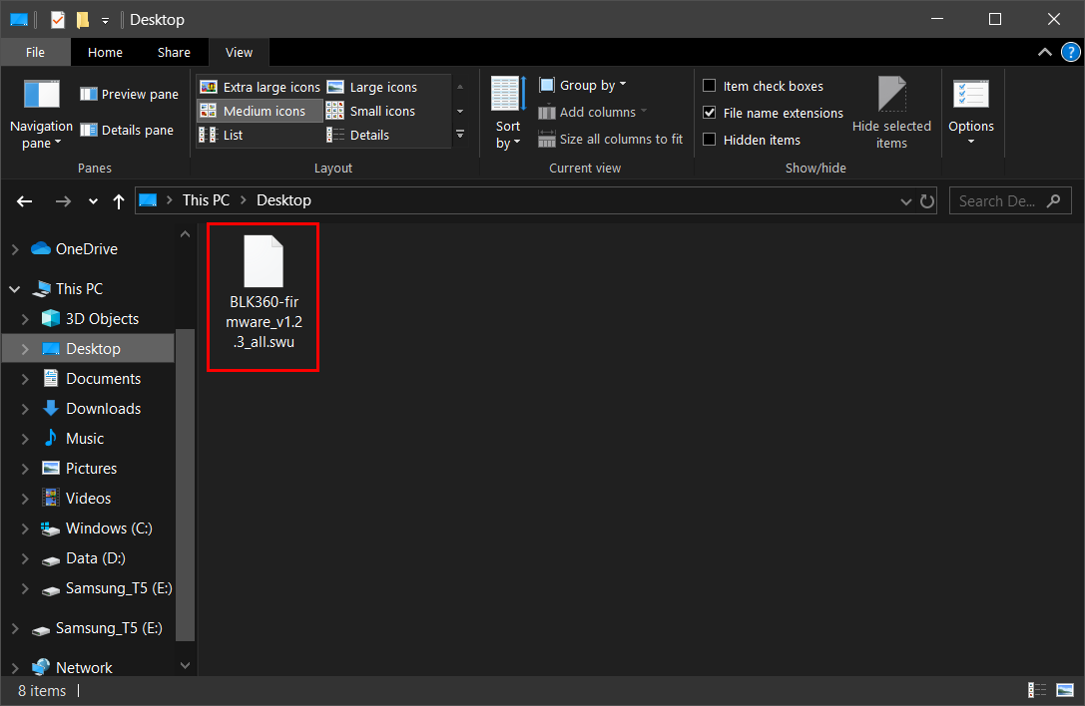

- You will see the progress as the firmware is updated.

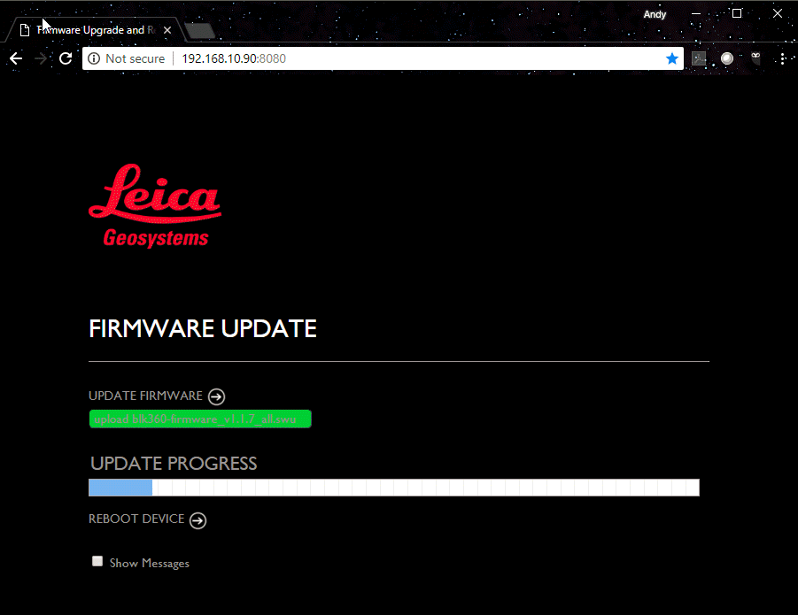

- Once the firmware has successfully transferred, you will have the option to reboot. Click ‘REBOOT DEVICE.’

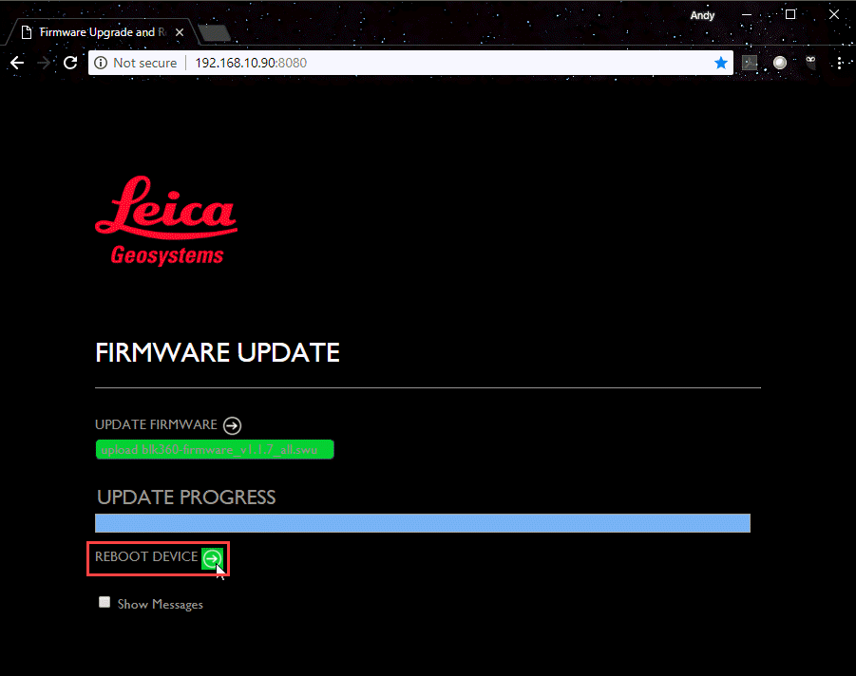

- The BLK360 will reboot with the new firmware version.

